

**Software Requirement Specification**

**“Credit Limit Portal”**

2023.12. 14

***Uncontrolled copy if printed/ photocopied (unless specified otherwise)***

|  |
| --- |
| ***NOTICE:*** |
| ***Information contained in this document is classified LG Confidential Proprietary. No person outside the LG Group shall have access to the information contained in this document unless business needs dictate, otherwise. It is the responsibility of the person knowing the information contained in this document to ensure confidentiality of information contained in it and always preventing unauthorized access to this document.*** |

Contents

Document Control 2

Business Process Overview: 3

Process: 4

Out OF Scope: 5

Scope 5

Use Case 001 to 010 5

Platform & Technology 26

# Document Control

| **Date** | **Author** | **Version** | **Change Reference** |
| --- | --- | --- | --- |
|  |  |  |  |
| 10-Jul-2023 | Amit Rajput | V1.0 | Initiation |
| 14-Dec-2023 | Adarsh jain | V1.1 | Discussed on Credit Limit module and its different personas with Ankit Shrivastav |
|  |  |  |  |
|  |  |  |  |

# Business Process Overview:

|  |  |  |  |
| --- | --- | --- | --- |
| **Particular** | **Existing** | **Current** | **To Be** |
| Portal / System | Credit Limit | Manual | On Same portal with new system / Module |
| Credit Limit Request | Branches use to request HO for exceeding their Credit Limit | Manual | **Phase-1** :Branches will have the ability to request for exceeding their Credit Limit via Portal |
| Credit Limit List | NA | Manual | Admin will be able to set the New limit and update the Status |
| Notes Master | NA | Manual | Admin will have the ability to Update the Notes that can be viewed by the Branches |
| Enclosed Financial Statement | NA | Manual | 1. The administrator can both designate the status and define conditions for branches, thereby determining whether the field should be mandatory or optional. 2. Admin will be able to make it Active/ Inactive 3. Admin will be able to view the Upload History as well as Edit them if needed. 4. Admin will be able to Download the Template and Upload it by updating it 5. Admin will be able to filter the Attachment list with Header Code, FY , FY type 6. Admin can download the attachments |
| Lookup Master | NA | NA | 1. Admin will be able to |
| Future Uses | NA | NA | We can think its utilization for vendor code management / bank account confirmation etc. in case of any modification / changes of registered vendor, MSME registration We can also use it for Agreement control management & reporting |

# Process:

|  |  |  |  |
| --- | --- | --- | --- |
| **Sr. No.** | **Step / Process** | **Activity** | **User** |
|  | * The Branch user will receive the request from various Headers( Outside the Portal) and using the Credit Limit portal, Branch will send theCredit Limit increase Request to the Admin/HO on behalf of headers. The Admin/HO will download the template and updating the excel file with New Limit and status. Once the New Limit is set and the excel file is uploaded the Admin/Ho can click on the Submit button. * Then the Mail will be sent to the Branch user, regarding the updated Credit Limit. |  |  |
| 1 | Branch users will view the Credit limit request form where they will have the ability to enter the Requested Credit limit also they can enter the Collection amount, Future Sales Plan amount . | System | Branch User |
| 2 | The Form once completed the branch user will click on the Submit button with which the mail will be sent to Admin, Branch AM, Credit Limit team. | System | Branch user |
| 3 | Admin will be able to view the Credit Limit request under the Credit Limit List section where they can view all the requests which can be filtered by entering the header code, Select Ctrl_Au, Select Status. | System | Admin |
| 4 | The admin can establish a new credit limit and modify the credit limit status. Subsequently, upon clicking the "Submit" button, notification emails will be sent to the administrator, branch account manager (BAM), and the credit limit team. | System | Admin |
| 5 | The Admin can also view the Master updates by clicking on the Settings icon present on the screen. | System | Admin |
| 6 | The Branch User will also view the Notes on their portal which is managed from the Admin Panel | System | Branch User |
| 7 | By accessing the Notes Master, the admin can input notes and define their status. The Notes whose status has been marked Inactive will not be viewed on the Branch user portal | System | Admin |
| 8 | The Branch user will be able to view the Enclosed Financial Statements with the fields under are managed from the Admin | System | Branch User |
| 9 | The admin can designate the status of the field within Enclosed Financial Statements by choosing from the radio button options, determining whether to set it as mandatory or require the branch user to upload a file. | System | Admin |
| 10 | The Branch user will be able to view the Insurance details such as Digit etc that is managed from the Admin Portal | System | Branch User |
| 11 | The Admin will be able to download the template and upload the file with details in the same format as mentioned in the format to set the Insurance details | System | Admin |
| 12 | The Branch user will be able to view the Sales history (Last two years) on their portal with Total, avg, Max sales which is uploaded by the Admin. | System | Branch User |
| 13 | On the basis of Last two years sales data the Branch user will be able to view the Last six months payment trends and will be able to enter the collection amount for every month | System | Branch User |
| 14 | The Admin by clicking on the Sales Upload Master will be able to download the Template and by entering the details will be able to upload the sales file | System | Admin |

# Out OF Scope:

* 1. Any RPA Process
  2. Any process which was not included in the existing document.
  3. Auto purging

System Actors

Following are the only system Actors.

|  |  |
| --- | --- |
| Actor | Use Cases accessible |
| Branch User | 001 |
| Admin | 002, 003,004,005, 006 |

# Scope

Need to save all entered & outcome data in Dealer net. Portal auto login via Dealer Net Plus for all LG roles, Vendor login through Vendor Code and DMZ URL**.** Dynamic Menu binding is required with Query String for each user session.

# Use Case 001 to 007

|  |
| --- |
| **USE CASE: 001** |
| **Use Case: Branch User >Request Credit Limit**  Use Case: This use case outlines the capabilities of a Branch user to request permission from the Admin for exceeding their credit limit by furnishing the necessary details. |
| **NFR [Non-Functional Requirements]:**   1. The features of this use case would require access to System access Roles defined in Credit Limit Portal. |
| **Pre-Condition**   1. The User has successfully logged in into the portal using their verified credentials. 2. The User has to click on the Credit Limit dropdown from the Header where they will be able to view the “Credit Limit Request option” which will redirect them to the form. |
| **Post Condition**   1. Access credentials of required Branch user roles are updated in the system. |
| **Actors**   1. Only an actor with Branch user access will have access to this use case. |
| **Flow:** The user will be provided with capabilities to add and Fetch following data:   * The user will be able to view the Credit Limit Request form with following details   + The user will view the Static details the data form which is managed from the admin portal     - Header code       * This will be auto generated and cant be manipulated by the Admin       * Admin by entering the Header code will be able to view the Branch details more precisely     - Names     - Ctrl_Au     - Insurance       * This will also be managed form the Admin side       * Admin has the ability to mark the Insurance as Active/ Inactive also will be able to Update the Name.     - Insurance code   + Sales History Last two years (Amt in Lakhs)     - The Branch user will be able to view the list of all the data here.     - The details in the List is managed by the Admin> Credit Limit Request> Sales Upload Master       * Admin can Download the template and using the same format file can be uploaded       * Uploaded file can be viewed on the Branch user side with Avg, Total , Max sales.   + Branch user will then view their Current Credit Limit (Non editable numeric field)   + The Branch user will be able to enter the Credit Limit Request.(Numeric only field)   + Once the above form is completed the Branch user will have to provide their Future Sales Plan (Next 6 Months)     - Here the Branch user will enter the exceeding Amount of credit they are requesting.     - Numeric only field   + Once the above form is completed the Branch user will have to provide their Future Sales Plan (Next 6 Months)     - Here the Branch user has to provide the details of the upcoming 6 months Sales Plan     - The Branch user will provide the target sales amount for every month here.     - The Branch user will view the Remarks text field where they will be able to enter the details as per their requirements       * Alphanumeric, Special characters allowed.   + The user will then view the Enclosed Financial Statements sections here with following details:     - This section is completely managed by the Admin where they have the following ability:       * To set the field status (Received, Need, Compulsory, Not Required)       * Set field type to Mandatory or not       * Upload file will be there or not     - The user here will view the Name, Upload file option if setted by Admin   + Then user will view the Notes that is also being managed from the Admin side> Credit Limit Request> Note Master     - Admin will be able to add the Note and set the Status to make it as Active/Inactive     - If status is set to Active that can be viewed by the User     - If marked Inactive will not be viewed on the User end  |  |  |  | | --- | --- | --- | | **Lookup Master form** | | | | **Field** | **Mandatory** | **Type** | | Collection | Y | Numeric | | Credit Limit Request | Y | Numeric | | Amount | Y | Numeric | | Choose file | Managed by Admin | Excel File | |
| **Alternate Flow**  None |
| **Exceptions**  NA |
| **Reports**  No reports are identified. |
| **Additional Features:** |

**Data Sample:**

|  |  |
| --- | --- |
| Role Id | Role Name |
| 1 | Admin |
| 2 | Branch User |

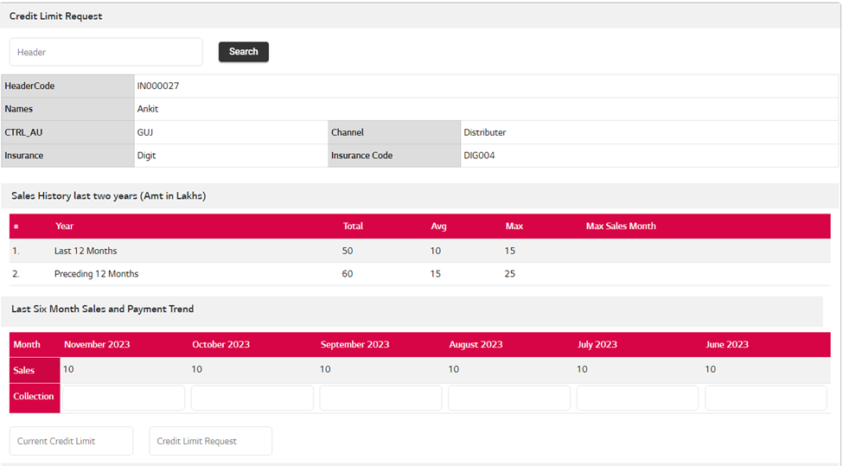

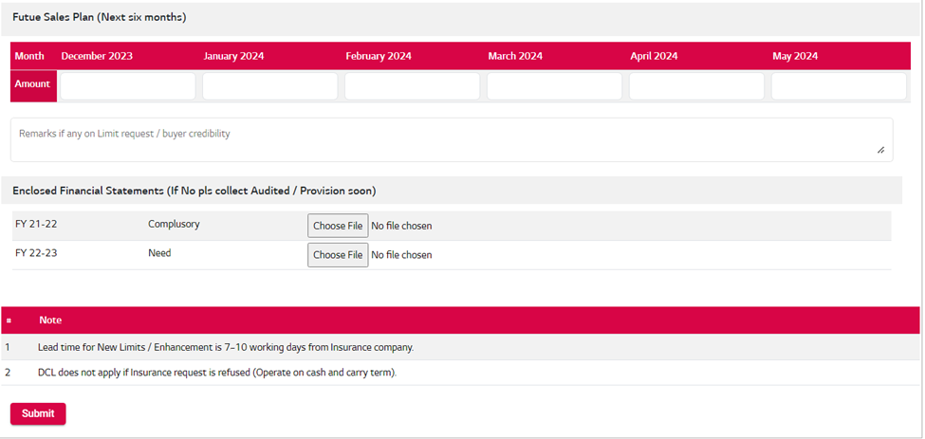

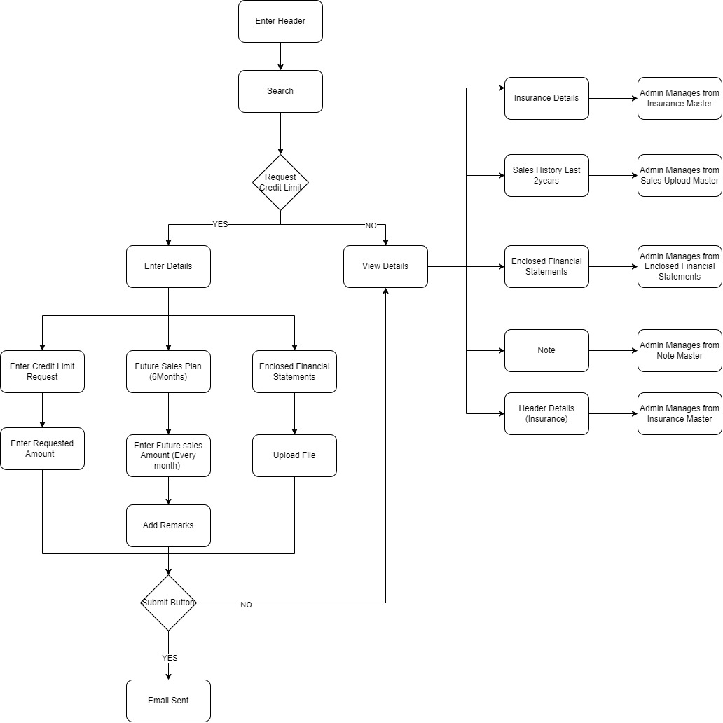

|  |
| --- |
| **USE CASE: 002** |
| **Use Case: Admin >Request Credit Limit**  Use Case: This use case outlines the capabilities of a Admin to view the requests from the Branch Users for exceeding their credit limit by furnishing the necessary details. |
| **NFR [Non-Functional Requirements]:**   1. The features of this use case would require access to System access Roles defined in Credit Limit Portal. |
| **Pre-Condition**   1. The Admin has successfully logged in into the portal using their verified credentials. 2. The Admin has to click on the Credit Limit dropdown from the Header where they will be able to view the “Credit Limit Request option” which will redirect them to the form. |
| **Post Condition** |
| **Actors**   1. Only an actor with Admin access will have access to this use case. |
| **Flow:** The Admin will be provided with capabilities to view the following data:   * The Admin will be able to view the Credit Limit Request form with following details   + The user will view the Static details the data form which is managed from the admin portal     - Header code       * This will be auto generated and cant be manipulated by the Admin       * Admin by entering the Header code will be able to view the Branch details more precisely     - Names     - Ctrl_Au     - Insurance       * This will also be managed form the Admin side       * Admin has the ability to mark the Insurance as Active/ Inactive also will be able to Update the Name.     - Insurance code   + Sales History Last two years (Amt in Lakhs)     - The Admin will be able to view the list of all the data here.     - The details in the List is managed by the Admin> Credit Limit Request> Sales Upload Master       * Uploaded file can be viewed by the Admin with Avg, Total , Max sales.   + Admin will then view their Current Credit Limit (Non editable numeric field)   + The Admin will be able to view the Credit Limit Request.(Numeric only field)   + The Admin will be able to view the Last six minth data that has been uploaded by him from the Sales Upload Master section.     - Here the Admin can view the details of the upcoming 6 months Sales Plan of the Headers   + The Admin will then view the Enclosed Financial Statements sections here with following details:     - This section is completely managed by the Admin where they have the following ability:       * To set the field status (Received, Need, Compulsory, Not Required)       * Set field type to Mandatory or not       * Upload file will be there or not   + Then user will view the Notes that is also being managed from the Admin side> Credit Limit Request> Note Master     - Admin will be able to add the Note and set the Status to make it as Active/Inactive     - If status is set to Active that can be viewed by the User     - If marked Inactive will not be viewed on the User end |
| **Alternate Flow**  None |
| **Exceptions**  NA |
| **Reports**  No reports are identified. |
| **Additional Features:** |





|  |
| --- |
| **USE CASE: 003** |
| **Use Case: Admin> Credit Limit List**  Use Case: This scenario delineates the Admin's capability to establish a new limit, adjust the status, and optionally append remarks if necessary. |
| **NFR:** The system must be able to handle a scalable growth in the number of credit limit modification requests initiated by branch users. |
| **Pre-Condition**   1. The Admin has to click on the Credit Limit List from the options provided under Credit Limit Header which will redirect them to the 2. Read access for all required master data sets. |
| **Post Condition**  Email will be sent to the Branch user once the Admin clicks on the Submit button. |
| **Actors**  HO Person will be authorized to Register new vendor or Modification in Existing Registered Vendor |
| Flow   * Admin when clicks on the Credit Limit dropdown from the Header will view the Credit Limit List option * On the Credit Limit List screen the Admin will view the Credit Request Details in the List form as mentioned below. * Admin will be able to Filter the list by   1. Header Code (Input Field)   2. Select Ctrl AU (Dropdown field)      + Here the Admin will be able to Select the Branch   3. Status (Dropdown field)      + Pending      + Closed * Admin will have the ability to to download the template and by making the changes will be able to upload the same.   1. Set the New Limit by entering the Numeric value in the field   2. Add the Remark   3. Update the status by clicking on the Dropdown * Once the updates are done the Admin can select the Multiple Request and Click on the Submit button, an Email will be sent to the Branch with the Updated Limit and File attached with above mentioned details such as:   1. Remark   2. New Limit   3. Full List * Admin can also view the Masters Updated list by clicking on the Settings icon which includes   1. Serial No.   2. Types   3. Last Update Date (Format ex: 20 - Nov- 2023) * Complete flow will be:   1. When the Branch user sends the request then the state will be Request   2. Admin receives the request and checks with Insurance company on the backend whether the Header is valida or not   3. Once Admin is satisifed then in that case Admin will download the template and after making updates and setting the new limit and status the Admin will upload the file and the status will be chnaged to Close. * Admin can perform Multiple Selection in the List by clicking on the Checkbox.  |  |  |  |  |  |  |  |  |  |  | | --- | --- | --- | --- | --- | --- | --- | --- | --- | --- | | S.No | Header Code | Header Name | Ctrl AU | System Limit | Limit Request | Request Date | New Limit | Status | Remark | | 1 |  |  |  |  |  |  |  |  |  | | 2 |  |  |  |  |  |  |  |  |  | | 3 |  |  |  |  |  |  |  |  |  | | Other Features | | Template Download and Bulk upload | | | |  |  |  |  | |  |  |  |  |  |  |  |  |  |  | | Button Details: | | | | | |  |  |  |  | | Submit  Action> Preview the full details within the List  Settings : To View the Masters Update  Status  Search  Paganing Buttons  Previous  Next  Last | | | | | |  |  |  |  |   3. Entry Screen and Grid View   * 1. Textbox : - Header Code   2. Dropdown: -, Ctrl AU, Status,   3. Save, Cancel, Upload, Template download, Export Button   4. Grid View   5. Paging button * Master screen to manage all vendors on this page. * Admin can view all the Credit Limit requests here in the List form and has the ability to Set the New Limit. * In the New LImit field following validations will be there:   1. Numeric only   2. Can Enter value more than Current Limit * In the Remark field following validations will be there:   1. Alphanumeric * NOTE: * 1. The Admin will have the upload and download template option with which the status is managed   1. The status will be Request when the Branch user rasies the request from their portal   2. The Admin will view the List of requests      + Admin will be able to download the template set the Nerw Limit and status and will upload the file.      + If Admin does not update the status the status will same only. |
| **Alternate Flow**  None |
| **Exceptions**  Exception are System's expected behaviour in the event of incorrect user actions or other failures. |
| **Reports**  The anticipated input will result in corresponding outputs. The newly entered limit can be accessed through the Branch Portal, enabling users to view instances where their credit limit has been exceeded. |

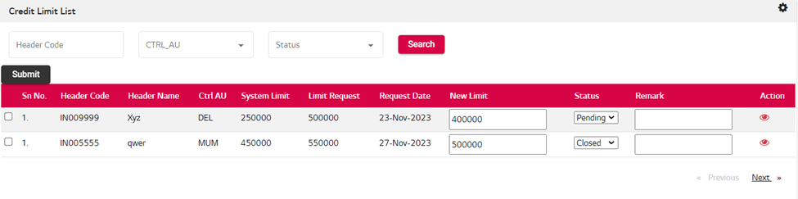

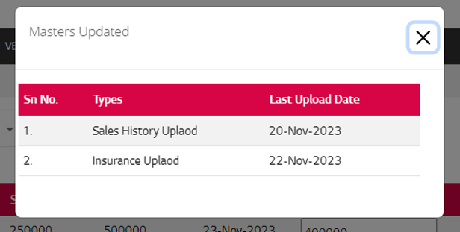

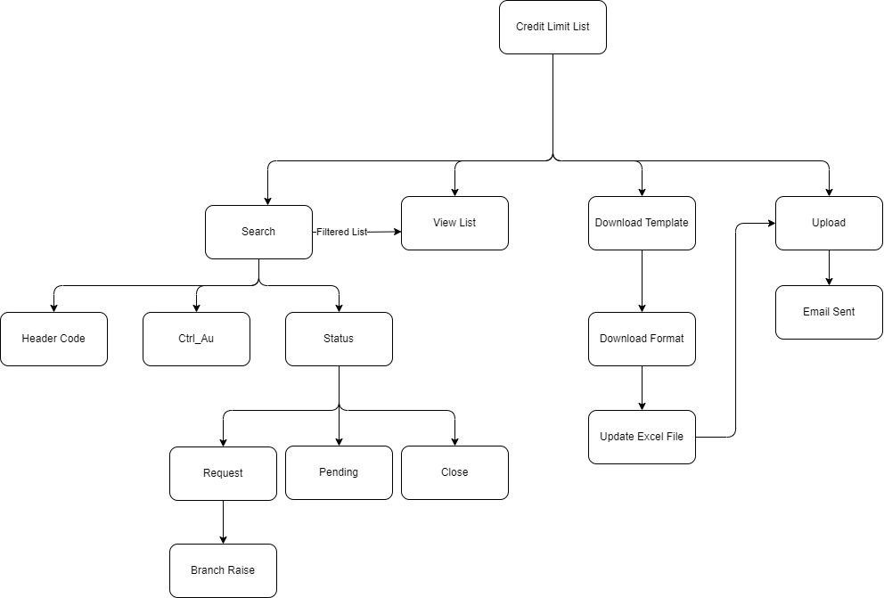

|  |
| --- |
| **USE CASE: 004** |
| **Use Case: Admin > Lookup Master**  Use Case: This particular case entails the Admin's capability to review and modify insurance details, including the name and description. Additionally, the Admin possesses the capability to switch the status of the insurance name between Active and Inactive. |
| **NFR [Non-Functional Requirements]:**   1. The system must provide a user-friendly interface for the Admin to view and update insurance details |
| **Pre-Condition**   1. The Insurance radio button will be selected by the Admin to proceed. 2. Read/Edit access for all required master data sets. 3. By default, full listing will be viewed on the entry screen which can be filtered. |
| **Post Condition**   1. Added Lookup value can be viewed on the list with most recently added will be on top of the list 2. Once a Lookup value is edited, the update reflects across all listings where it is utilized. 3. **If the Lookup value status has been marked Inactive then in that case empty space will be shown.** |
| **Actors**   1. Admin will have the capability to Edit/Update/ Add the Lookup value, description and status. 2. Only Admin can change or modify the Dataset 3. Admin can Export the Listing in Excel Format |
| **Flow:** Mandatory Data set for following is expected to be maintained by the Admin   * Admin will view the Lookup value field with the Insurance option. * Admin will be able to create by entering the Lookup value, description and Status * The Lookup value created can be viewed on the List with the most recent on top. * Admin can edit the Lookup details by clicking on the Edit icon present on the list. * Admin can also preview the list by clicking on the eye icon present on the list.  |  |  |  | | --- | --- | --- | | **Lookup Master form** | | | | **Field** | **Mandatory** | **Type** | | Lookup name | Y | Radio button | | Lookup value | N | Text | | Lookup description | N | Text | | Status | N | dropdown |  |  | | --- | | Button Details: | | Save  Cancel  Export in Excel  Edit  Preview  Paganing Buttons  Previous  Next  Last |  1. Entry Screen and Grid View    1. Dropdown: - Status    2. Export, Save, Cancel Button    3. Grid View    4. Paging button 2. Admin can change the details as per requirement. 3. Export uploaded details. |
| **Alternate Flow**  NA |
| **Exceptions**  Admin has to select the Lookup name Radio button to |
| **Reports**  Only Excel export of list will be provided |
| **Additional Features:** |

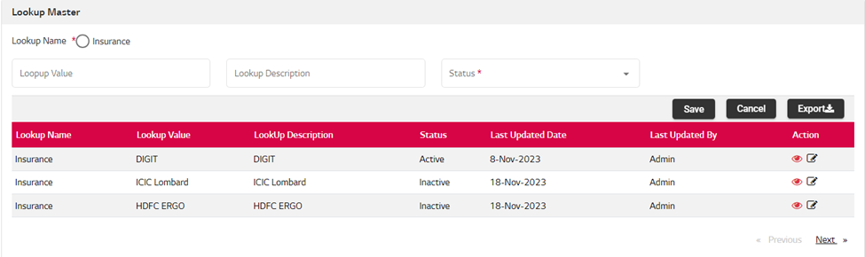

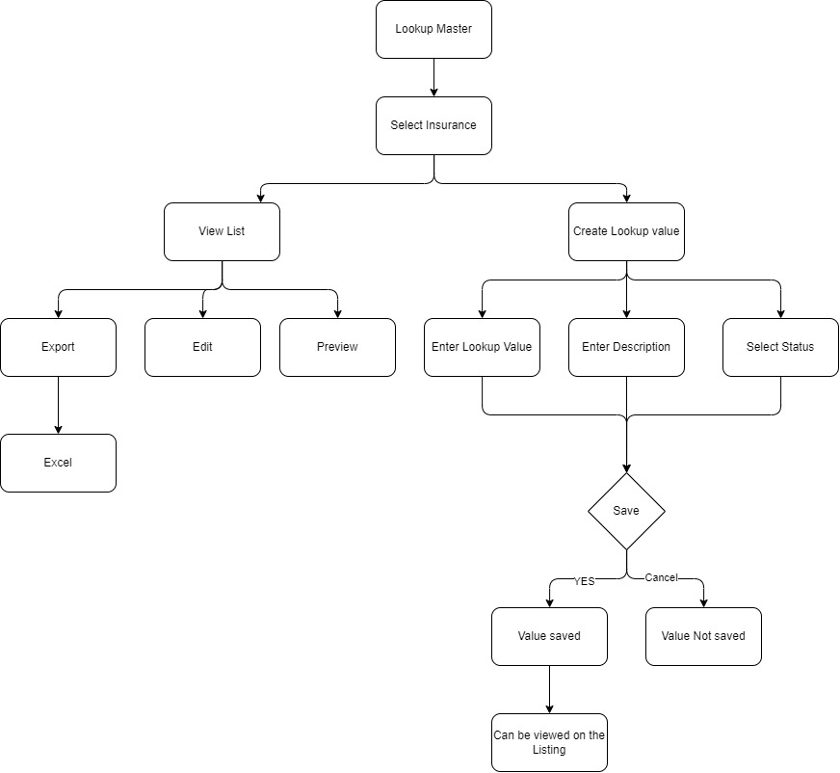

|  |
| --- |
| **USE CASE: 005** |
| **Use Case: Admin> Enclosed Financial Statement**  Use Case: This use case outlines the process where the administrator configures fields, manages templates for data input, oversees the list of uploaded items, and has the option to update templates for consistent data management.  Admin will have the ability to perform the following:   1. Will have the ability to set the Field type as    1. Received    2. Compulsory    3. Need    4. Not Required 2. Admin can set the field as Mandatory    1. Yes    2. No 3. Upload    1. Yes    2. No 4. **Use Case Steps:**    1. Field Configuration:       1. Admin logs into the system.       2. Admin navigates to the field configuration section.          1. Admin sets specific fields as mandatory and enables file upload for selected fields.    2. Template Management:       1. Admin downloads a template reflecting the configured fields and settings.    3. Admin may update the template, modifying field configurations if necessary.    4. Admin uploads the updated template to apply changes system-wide. |
| **NFR:** |
| **Pre-Condition**   1. Admin has to select the field type once selected they will be able to download the template and upload the file 2. The file uploaded can be viewed on the list |
| **Post-Condition**   1. File once uploaded can be viewed on the list with most recent on top 2. The field type selected here can be viewed by the Branch user under Enclosed Financial statement |
| **Actors**   1. Admin will be able to set the field to be mandatory or optional 2. End user will view the updated under Enclosed Financial statement |
| **Flow:** Following Master data set will be managed by Admin.   |  |  |  | | --- | --- | --- | | **Enclosed Financial statement** | | | | **Field** | **Mandatory** | **Type** | | Financial Year Status | Y | Radio button | | Mandatory | Y | Radio button | | Upload | N | Radio button | | Status | N | dropdown | | Choose File | N | Upload EXCEL | | Header code | N | Text | | Financial year | N | checkbox | | FY type | N | dropdown |  |  | | --- | | Button Details: | | Save  Cancel  Data Export in Excel  Upload  Template Download  Download file  Search  Paganing Buttons  Previous  Next  Last |   Following are the use case flow for creation of a new Master Data set.   1. Entry Screen and Grid View with action Buttons    1. Dropdown: - Status, Financial Year, FY type    2. Export, Search Button    3. Paging button 2. If admin designates a field as "Mandatory" and label it as "Compulsory," with the upload option set to "Yes," branch users must undertake this task on their portal to fulfill the credit limit increase request form. 3. The field once created can be viewed below in the list with the most recently created will be on top.    1. Admin will have the ability to Export the list in Excel. 4. Admin will have the ability to download the template and then upload the file and both records can be viewed separately in the list form 5. Admin will have the ability to Filter the Attachment List 6. Note:    1. If Admin selects any tag for Finanical year status such as :       1. Received       2. Compulsary       3. Need       4. Not Required    2. And then Admin selects Mnadatory field as Yes then by default Upload field will be Auto selected as yes    3. If Mnadatory is selected as No then Admin will have to decide whether to select as Yes/No on the Upload field |
| **Alternate Flow**   1. As of now this is OUT-OF-SCOPE. |
| **Exceptions**  Exceptions are the System's expected behaviour in the event of incorrect user actions or other failures. |
| **Reports**  Only Excel export will be provided only for new development |
| **Additional Features:** |

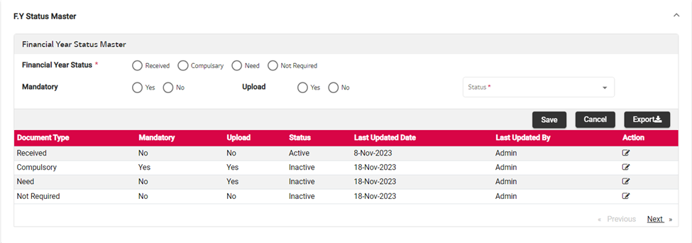

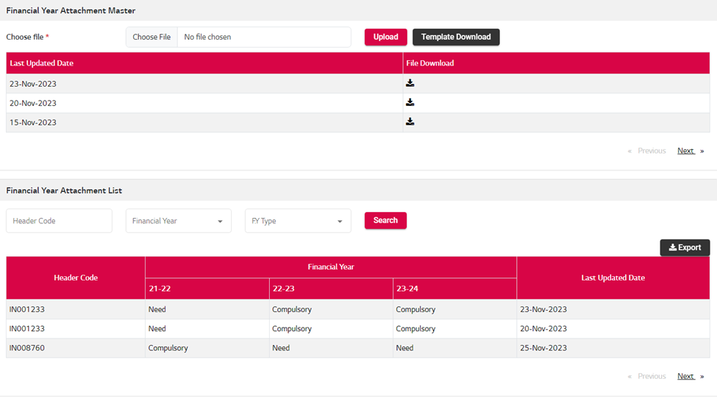

Note: - The file that is to be uploaded should be in the same format as downloaded from the template if there is a change in data type as well as field change error message will be prompted.

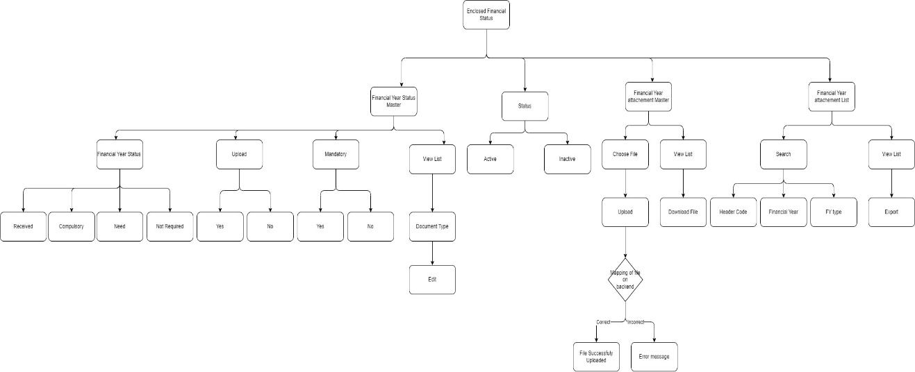

|  |
| --- |
| **USE CASE: 006** |
| **Use Case: Admin> Sales Upload Master**  Use Case: This use case outlines a scenario where the admin downloads a template, populates it with sales data, uploads the file, and then branch users can view the updated sales amounts. Additionally, the admin can access a listing and historical view of all uploaded files, enhancing visibility and control over sales data management.   * Template Download by Admin:   + Admin logs into the system.   + Admin navigates to the template management section.   + Admin downloads a template with predefined fields for sales data. * File Preparation by Admin:   + Admin populates the downloaded template with sales data, ensuring data accuracy and completeness. * File Upload by Admin:   + Admin returns to the system and navigates to the file upload section.   + Admin selects the prepared file and uploads it to the system. * Sales Amount Calculation:   + The system processes the uploaded file, calculates sales amounts based on the provided data, and updates the sales records. * Sales Amount Display for Branch Users:   + Branch users log into their portals.   + Sales amounts are displayed on the branch user interface, providing real-time updates on recent sales data. * Listing and History View for Admin:   + Admin accesses the file history section.   + Admin views a listing of all uploaded files, including details such as upload date, status, and associated sales amounts.   + Admin can click on individual files to view historical data and changes over time. |
| **NFR:**   1. The system will throw an error if the being uploaded is different from the downloaded template |
| **Pre-Condition**   1. Admin should be on the Sales Master Screen then by clicking on the Template download the file in excel format will be downloaded. 2. The file uploaded can be viewed on the Branch user’s end as well as under the Credit Limit request section. |
| **Post-Condition**   1. OTP Generate & Submission for final Submission. |
| **Actors**   * Admin   + Use Case: Template Download and Upload with Error Handling     - Template Download:       * Admin downloads a template for sales data.     - File Preparation with Errors:       * Admin populates the template with sales data, introducing intentional errors.       * Errors may include missing values or incorrect data formats.     - Error Notification:       * Admin attempts to upload the file with errors.       * The system detects errors and provides detailed error notifications, highlighting the rows or fields with issues.     - Error Resolution:       * Admin corrects the errors in the template and re-uploads the file.       * The system verifies the corrected file and processes it without errors. * Branch User   + The Branch user can view the Sales data in Total, Avg, Max form.   + On the basis of uploaded sales data the user will also be able to view the last six month sales and will have the abiity to enter the collection amount. |
| **Flow:**   |  |  |  |  | | --- | --- | --- | --- | | **Sales Upload Master** | | | | | **Field** | **Mandatory** | **Type** | | Choose File | N | Upload>Excel file | | Header Code | N | TextBox | | Closing Month | N | Dropdown | | Button Details: | | | | Upload  Template Download  Search  Download  Paganing Buttons (Optional)  Previous  Next | | |  * Entry Screen and Grid View   1. Dropdown: - Status,CLosing Month   2. Upload, Template, Export, Search, Submit Button   3. Grid View   4. Paging button(Optional) * Admin can upload the excel file for the Sales month * Branch Users can view the details such as Sales history last two years, other details added by the Admin * Admin can upload the Template document and following the same can upload the file. * There will be a Sales upload history   1. List can be filtered by following ways:      + Enter Header Code      + Select Closing Month |
| **Alternate Flow**  None |
| **Exceptions**  Manually data cannot revise after Final submission. History maintenance in case resubmission. |
| **Reports**  No reports are identified. |
| **Additional Features:** |

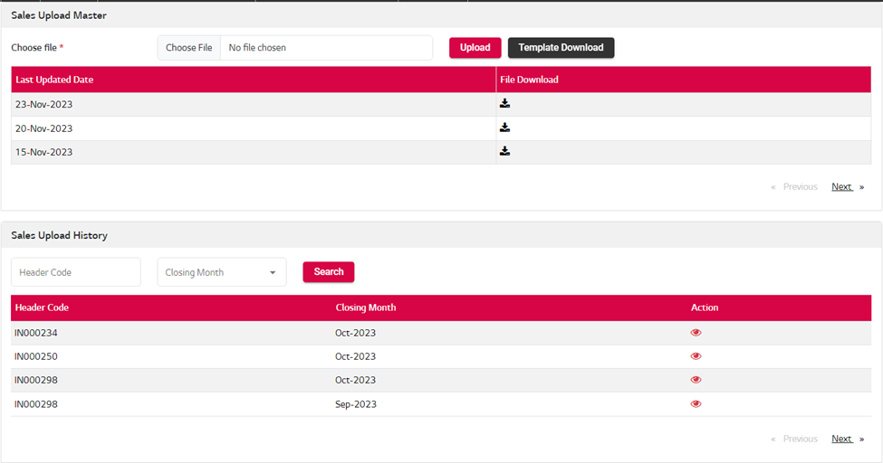

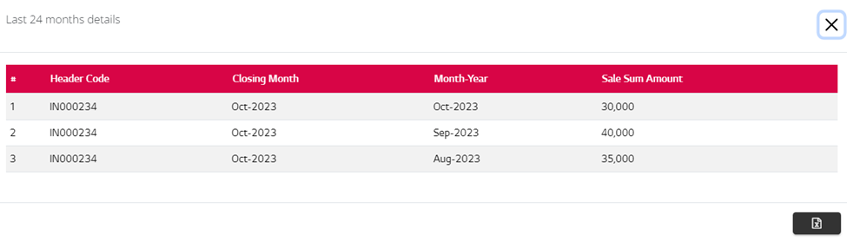

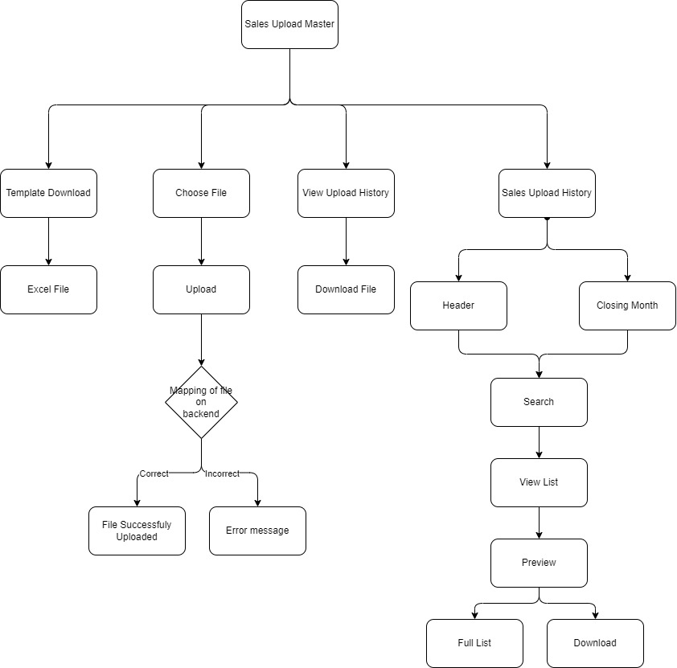

|  |
| --- |
| **USE CASE: 007** |
| **Use Case: Admin > Insurance Master**  Use Case: This use case outlines the process where the admin configures insurance details by downloading templates, entering data, and uploading. The admin can then view the history of uploads, providing transparency into when insurance configurations were made and any changes over time.   * Template Download for Insurance Master:   + Admin navigates to the Insurance Master section.   + Admin downloads a template for configuring insurance details. * Data Entry in the Template:   + Admin views the downloaded template, which includes fields for Insurance Code, Insurance Name, and Current Limit.   + Admin enters the required details for each insurance entry. * File Upload for Insurance Master Configuration:   + Admin returns to the Insurance Master section.   + Admin uploads the completed template, populating the system with the configured insurance details. * History Viewing for Insurance Master:   + Admin accesses the history section within the Insurance Master module. * The Insurance details managed by the Admin can be viewed by the Branch User on their Portal   . |
| **Pre-Condition**   1. Branch User as required administrative access credentials to access this use case. 2. Admin should be on the Insurance Master screen where they will be able to download the template and upload it by adding the fields that can be viewed by the branch user |
| **Post-Condition**   1. The field uploaded can be viewed by the Branch user |
| * **Flow:**  Admin navigates to the Insurance Master section. * Admin downloads a template for configuring insurance details. * Admin views the downloaded template with fields for Insurance Code, Insurance Name, and Current Limit. * Admin enters the required details for each insurance entry in the template. * Admin returns to the Insurance Master section. * Admin uploads the completed template, populating the system with the configured insurance details. * Admin accesses the history section within the Insurance Master module. * The history section provides transparency into when insurance configurations were made and any changes over time. * Insurance details managed by the admin can be viewed by the Branch User on their portal.  |  |  |  |  | | --- | --- | --- | --- | | **Insurance Master** | | | | | **Field** | **Mandatory** | **Type** | | Choose File | N | Upload Excel | | Header Code | N | Text Box | | Limit Type | N | Dropdown | | Button Details: | | | | | Template Download  Upload  Submit  Search  Export  Paging Buttons (in case all vendors data on single page)  First  Previous  Next  Last | | | |  * Entry Screen and Grid View   1. Dropdown: - Limit type   2. Textbox: - Vendor Code   3. Upload, Template, Export, Search, Submit Button   4. Grid View   5. Paging button * Bam can access submitted data based on search parameters. * Click on any Particular vendor for claim reply & claim reply window form open for selected vendor. * Option 01- BAM can download & Upload the Template for claim Response. * Option 02-Enter Manually details the respective invoice in GridView. * Auto email to Particular vendor with all related claim details * Reply form filled by BAM. |
| **Alternate Flow**  None |
| **Exceptions**: |
| **Reports**   1. Data Export only in excel for |
| **Additional Features:** |

|  |
| --- |
| **USE CASE: 008** |
| **Use Case: Admin > Note Master**  Use Case: This use case outlines the process where the admin configures.   * Admin navigates to "Note Master" section. * Admin views existing notes. * Admin adds a new note:   1. Provides details (content).   2. Sets initial status (e.g., "Active").   3. Saves the new note. * Admin edits an existing note:   1. Selects a note for editing.   2. Modifies content or details.   3. Saves the changes. * Admin changes note status:   1. Selects a note.   2. Updates status (e.g., "Active" to "Inactive" or vice versa).   3. System reflects the updated status. * Admin deletes a note:   1. Selects a note for deletion.   2. Confirms deletion.   3. Note is removed from the system. * Admin views notes filtered by status:   1. Chooses to filter and view notes by status (e.g., "Active" or "Inactive").   2. System displays notes based on the selected status filter. |
| **Pre-Condition**  Admin should be on the Note Master screen then by clicking on the Note master they will be able to add the Note. |
| **Post-Condition**   * Admin successfully manages notes in the "Note Master" section (add, edit, change status). * System reflects changes in real-time. |
| **Actors**   1. Admin responsible for managing notes and their statuses in the Admin portal. |
| 1. **Flow: Admin Navigates to Note Master Section:**    * The Admin logs into the Admin portal and navigates to the "Note Master" section. 2. **Admin Views Existing Notes:**    * Admin views a list of existing notes in the "Note Master" section.    * The system displays information such as note content, date created, and current status. 3. **Admin Adds a Note:**    * Admin decides to add a new note.    * Admin provides details for the new note, including content and other relevant information.    * Admin sets the initial status of the note (e.g., "Active"). 4. **Admin Edits Note:**    * Admin can edit existing notes to update information or correct errors.    * Admin modifies the content or details of a selected note and saves the changes. 5. **Admin Changes Note Status:**    * Admin can change the status of a note to control its visibility.    * Admin selects a note and changes its status (e.g., from "Active" to "Inactive" or vice versa).  |  |  |  |  | | --- | --- | --- | --- | | **Note Master** | | | | | **Field** | **Mandatory** | **Type** | | Enter Note | N | Text | | Status | N | Dropdown | | Button Details: | | | | | Save  Cancel  Export  Paging Buttons (in case all vendors data on single page)  First  Previous  Next  Last | | | |  * Entry Screen and Grid View   1. Dropdown: - Status type   2. Textbox: - Note   3. Paging button |
| **Alternate Flow**  None |
| **Exceptions**: |
| **Reports**  Data Export only in excel for |
| **Additional Features:** |

# 

# 

# 

# 

# Platform & Technology

* Development (Angular Dotnet) & API
* Oracle (Database)